Kickstarter Report

Due : Monday, December 21, 2020 by 12:59 pm | By Melinda Eudy

# Background

Over $ 2 Billion has been raised using the massively successful crowdfunding service. But no every project has found success. Of the more than 300,000 projects launched, on a third have made it through the funding process with a positive outcome.

# Data Used

4,000 past projects with the following information: name of project; small burb about the project; project goal, project pledge, outcome, country, start and end dates, number of backers.

# Conclusions, based on the data provided

1. The most successful projects are Theatre – specifically plays, Music and the Film -Video (which has about a 50/50 chance of success).
2. The projects most likely to fail are Animation, Food Trucks and Video Games.
3. No matter what the project, if the goal is low, the project will not get off the ground.

# Limitations of the dataset

1. Experience of Project Leaders in the field of the Project could make a difference in success/failure rates.
2. Blurb not the same as the Scope of a project. It gives a short review of the intended results but nothing related to the work it would take to get there.
3. Length of Project. I calculated the time from start to finish – however it does not tell me what the intended timeline was. Did it take 30 days and fail, when it was scheduled to take 15?
4. Is the Goal also the budget? Is there room in the # for unexpected costs?

# Additional Graphs I considered

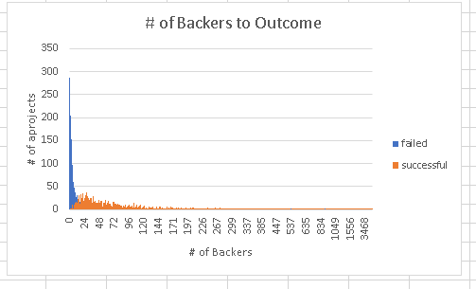

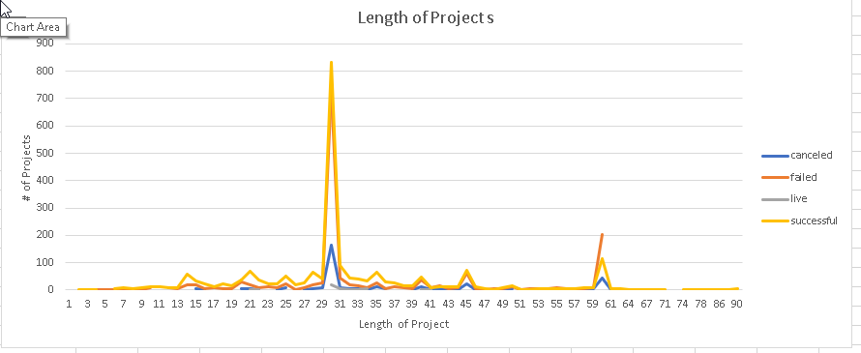

# Bonus Work Questions

1. Does the mean or median Summarize the data more meaningfully?

In this case, the median is would be the meaningful number. The Mean is higher than the median which means the data is skewed to the right (positively skewed).

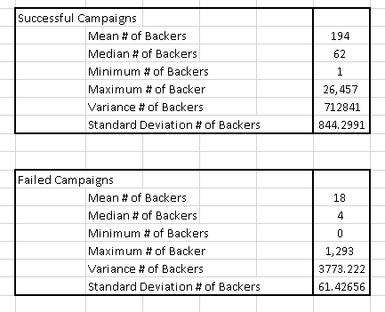

1. Is there more variability with successful or unsuccessful campaigns?

By using the additional charts, I determined that the number of backers and the length of the project has relationship to the success of the project. Most of the failed projects had a small number of backers, which led to a short project time period. The most successful projects appear where the arrow is pointing on the first chart.